**Virus Based Attacks with the help of TeraBIT Virus Maker**

**Tools Used: TeraBIT Virus Maker 3.2, Resource Reshaper**

**Attacker PC: Windows 7**

**Victim PC: Windows 7**

**Steps:**

**1)Open Terabit virus maker in your attacker pc:**

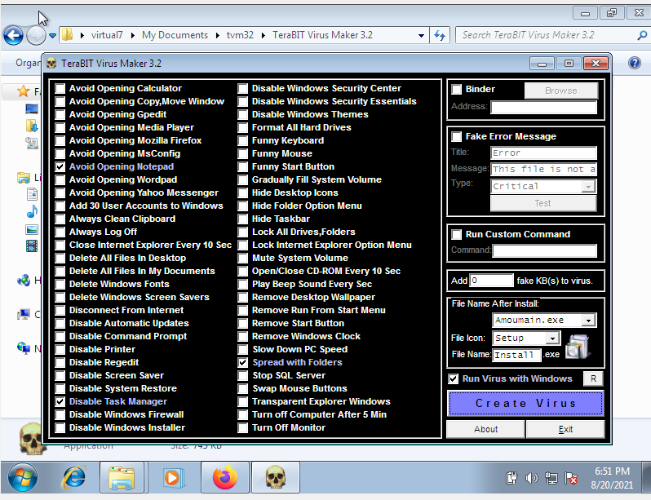

**2) The above mentioned options consist of various ways on effecting your pc , the options are explained by just reading it**

**3) Binder-> it binds the virus to the file our choosing,**

**So I choose the text file named Infom.txt**

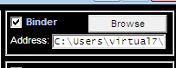

**4)You can choose the fake error messages it is optional and it’s not mandatory**

**5)Next if we want we can modify the files size and also change the file type**

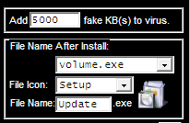

**6)Next I will click the options on what all attacks that take place**

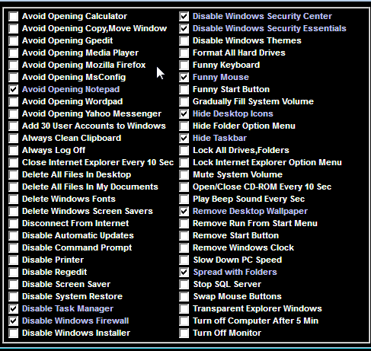

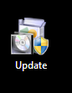

**7) After that I would change the icon of the file I created with the help of resource Hacker so it will look more genuine to the victim**

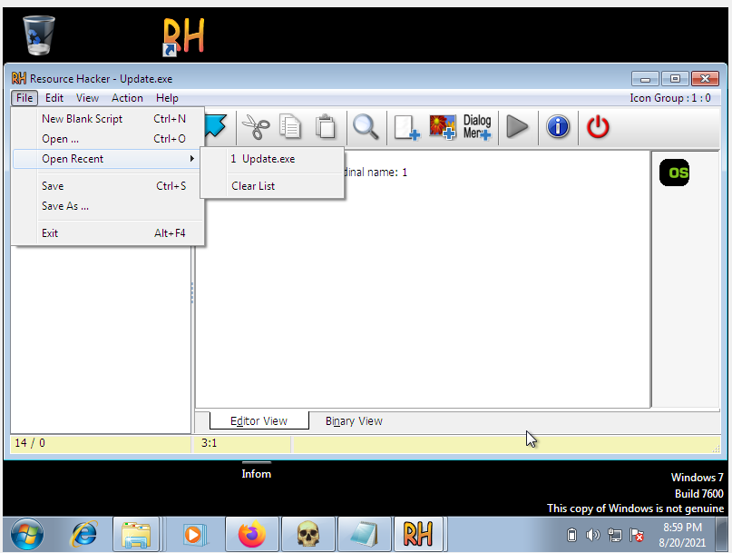

**8) Go to Resource Hacker, and in file select the file that consists of the virus and go to actions and then replace icon**

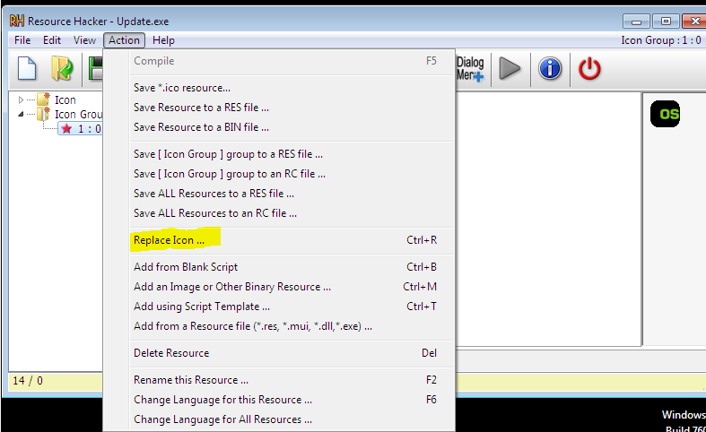

**Click on the icon of your preference and then click save in the menu**

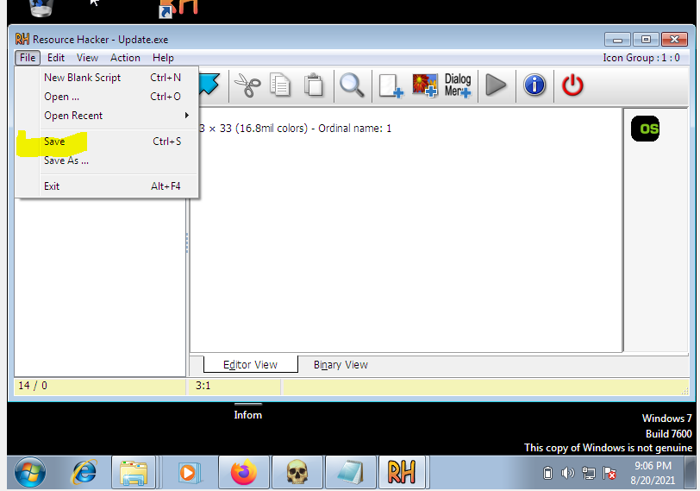

**Changes will be seen in the victims pc**

**8) If victim runs the program it will happen like this**

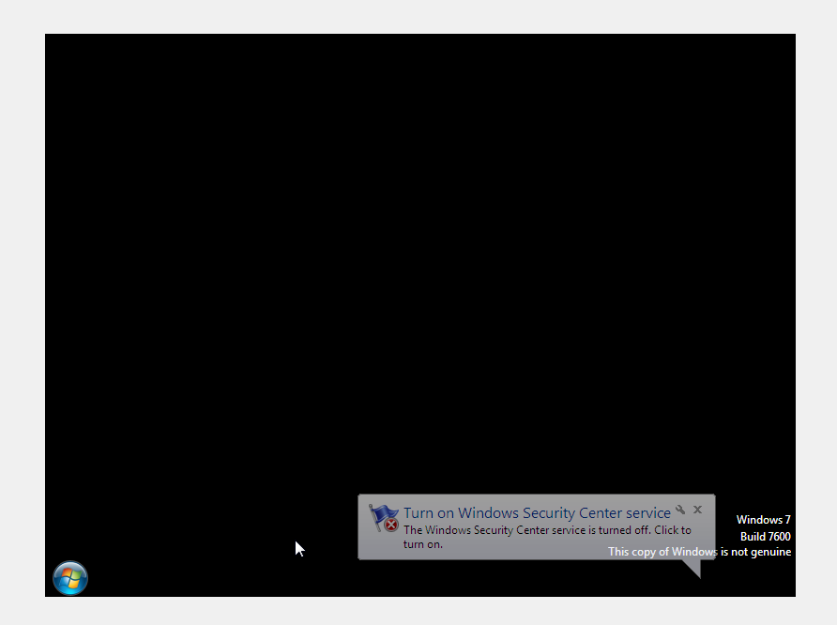

**How Prevent Virus Attacks**

* **Don’t open email attachments or click on hyperlinks from unknown senders.**
* **Use your spam blocking or filtering tools to block unsolicited emails, instant messages and pop-ups.**
* **Use passwords that are hard to guess and change them regularly. Do not store user names and passwords on websites.**
* **Exercise caution when downloading files from the Internet. Only download from trusted sources.**
* **Back up files on your personal computers regularly using an external hard drive.**
* **Don’t keep sensitive or private information stored on your computer. If you get hacked, information can be found.**
* **Don’t share access to your computer with strangers and turn off file-sharing.**